TREATMENT INFORMATION SHEET:
LOW FODMAP DIET

Management of diarrhoea in ulcerative colitis: multi-arm multi-stage of low FODMAP diet, amitriptyline, ondansetron, or loperamide: MODULATE

We are inviting you to take part in a study called MODULATE

- You should read this leaflet if you are interested in joining MODULATE.

- If you are eligible and choose to take part, a computer will randomly allocate you to one of the treatment groups (interventions).

- This information leaflet contains information about the low FODMAP diet intervention.

- Please take your time reading this information. Discuss it with your friends and relatives if you wish.

- Make a note of any questions you might have and discuss them with your doctor or nurse.

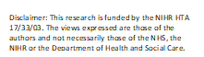

Contents

- What is a low FODMAP diet?

- How long will I be on the treatment for?

- How will my treatment be supported?

- What else do I need to do?

- What else do I need to know?

How to contact us:
If you have any questions about this study, please talk to the research nurse at
<< Enter research team contact details including phone number and email address>>
Thank you for taking the time to read this information sheet.

Most people with gut symptoms suspect that what they eat may impact their symptoms. Common dietary advice such as increasing fluid intake, reducing fibre intake, avoiding caffeine and spicy foods does not often give enough relief from symptoms of diarrhoea.
Following a low FODMAP diet might help people with stable ulcerative colitis (UC) who are still experiencing diarrhoea.

1. What is a low FODMAP diet?
A low FODMAP diet is an evidence-based dietary approach to help people with gut symptoms, which is well-established in the treatment of irritable bowel syndrome. It has a high success rate in particular in those who have a tendency to diarrhoea. Therefore, in this study we want to test the effectiveness of a low FODMAP diet in people with stable UC who are still experiencing diarrhoea.

FODMAP is an acronym for a group of complex molecules that can cause diarrhoea and other gut symptoms. It stands for fermentable oligosaccharides, disaccharides, monosaccharides and polyols. FODMAPs drag water into the small bowel, are poorly absorbed there, and then pass into the large bowel where bacteria rapidly break them down. In some people this can produce watery stools, diarrhoea or gases that cause bloating, wind and tummy discomfort or pain.

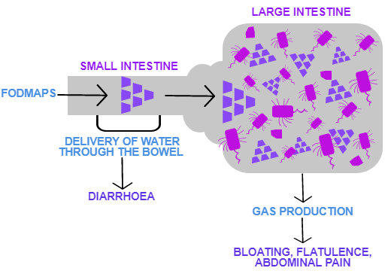
The low FODMAP diet works by restricting foods containing FODMAPs. FODMAPs are found in a wide variety of foods we commonly eat, such as onion, apple, bread, milk and honey.
Foods that contain FODMAPs will be removed from your diet and swapped for suitable alternatives, so that you can still eat a wide variety of foods, whilst the nutritional content of your diet is not compromised.
If your diarrhoea and symptoms improve during FODMAP restriction, you will be able to increase your food choices again. FODMAP reintroduction involves challenging high FODMAP foods. You will be able to find out which FODMAPs trigger your symptoms. You will then be able to find out how much of the foods in your usual diet you can put back in to keep control of your diarrheal symptoms. This process will be completed with the expert help of a FODMAP-trained dietitian.
2. How long will I be on the diet for?
Following a first appointment with a dietitian, you will be asked to follow a low FODMAP diet strictly for 8 weeks. At this point symptoms will be reassessed at another dietetic appointment. If you positively respond to the first phase of the diet, you will then be advised on how to reintroduce high FODMAP foods using a structured challenge process. You will have a telephone review with your dietitian after 16 weeks and will be invited to a final appointment 6 months after you join the study.

3. How will I be supported?
Before you start you will be instructed on how to follow this diet by a FODMAP-trained dietitian. The dietitian will assess will assess your usual diet so that you can successfully undertake the FODMAP restriction. You will receive up to date advice, and be informed about what foods to eat to help you make the dietary changes. There will also be guidance leaflets posted to you at home, which are especially helpful with grocery shopping and preparing meals.
During the first 8 weeks you will be able to contact an expert dietitian to support you in being able to successfully stick to the diet. Your dietitian will also provide you with information about additional materials and mobile applications that you may wish to use.
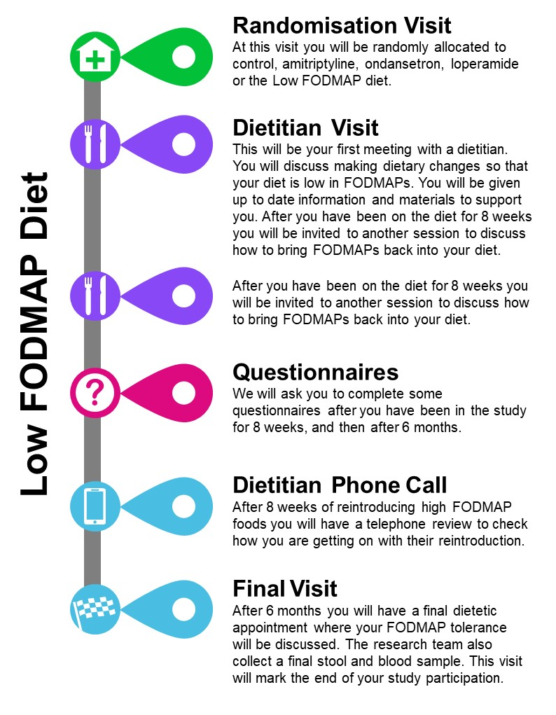

4. What else do I need to do?

- Questionnaires

You will complete some online or postal questionnaires three times. To help you remember to complete the questionnaires, the research team at the CTRU will send you reminders by email and text messages to your mobile phone. If you do not have an email or mobile phone, the research nurse can phone you.

- End of treatment

If you have a response to the low FODMAP diet, you will have a final dietetic appointment, via video call, phone call or at your hospital with the dietitian after 6 months from joining the study. You will have a further appointment with a research nurse at this time, to complete some trial assessments not specific to the low FODMAP diet.

5. What else do I need to know?
This diet involves making many dietary changes from a number of food groups. Through the dietitian’s guidance and support, you can meet your daily nutritional requirements. Whilst following the diet, you will be encouraged to eat a wide variety of suitable foods in line with the UK’s general healthy eating guide. For example, dietary fibre is a great food source for the good bacteria in your colon. Some high fibre foods, such as wholemeal bread, will need to be avoided during the trial and be replaced with low FODMAP, high fibre alternatives.
Please do not try out this diet on your own.
FODMAPs occur naturally in many foods and are common additions in packaged foods and medications, making it very difficult for the average person to detect and avoid them entirely without professional advice.
The dietary restriction is not made to encourage weight reduction, although any dietary restriction may lead to an overall calorie deficit. We will monitor your weight during the study.
You will be sent a £30.00 voucher since a change in diet may lead to higher costs for grocery shopping than what you are used to.
The low FODMAP diet was developed by researchers at Monash University in Australia. As part of our research, we will be sharing some of your data from food frequency questionnaires with Monash University. No personal details will be shared with them and this information will remain anonymous.

