TREATMENT INFORMATION SHEET: AMITRIPTYLINE

Management of diarrhoea in ulcerative colitis: multi-arm multi stage of low FODMAP diet, amitriptyline, ondansetron, or loperamide: MODULATE

We are inviting you to take part in a study called MODULATE

- You should read this leaflet if you are interested in joining MODULATE.

- If you are eligible and choose to take part, a computer will randomly allocate you to one of the treatment groups (interventions).

- This information leaflet contains information about the amitriptyline intervention.

- Please take your time reading this information. Discuss it with your friends and relatives if you wish.

- Make a note of any questions you might have and discuss them with your doctor or nurse.

Disclaimer: This research is funded by the NIHR HTA 17/33/03. The views expressed are those of the authors and not necessarily those of the NHS, the NIHR or the Department of Health and Social Care.
Contents

- What is amitriptyline?

- How long will I be on the treatment for?

- How will my treatment be given?

- What else do I need to do?

- What are the possible side effects of amitriptyline?

- Will amitriptyline interact with other medications?

- Warning and precautions to use of amitriptyline
How to contact us:

If you have any questions about this study, please talk to the research nurse at

<< Enter research team contact details including phone number and email address>>

Thank you for taking the time to read this information sheet.

What is Amitriptyline?

- Amitriptyline is a frequently used drug that has been used for more than 50 years. We believe it helps with irritable bowel syndrome with diarrhoea at a low dose because it changes bowel activity. Amitriptyline is sometimes used to treat depression. However, when being used for depression, it is given in much higher doses. This study will only be using small doses of amitriptyline, and it is being used because of its impact on bowel activity, rather than mood. In this study we want to test the effect of amitriptyline in patients with stable ulcerative colitis (UC) who are still experiencing diarrhoea to see if we see the same effect.

How long will I be on the treatment for?

- As part of the study, the maximum amount of time that you will be taking amitriptyline will be 6 months.
- You can choose to stop taking amitriptyline at any point should you wish, but please discuss this with your research nurse or doctor so they are aware of this and know the reasons why.
- After the study finishes, if you find that amitriptyline is effective at relieving your symptoms, you can talk to your doctor about continuing your treatment.

How will my treatment be given?

- Amitriptyline is a tablet treatment. You should swallow the tablet with a drink of water. If you chew it, it will taste bitter. You will receive your prescription for amitriptyline from your research team.
- To start with, you will begin treatment at a dose of 10mg per day (one tablet) at night time for 1 week. You will then have the option to take another 10mg in your second week (total 20mg/ two tablets daily taken together at night), and another 10mg during your third week (total 30mg/ three tablets daily taken together at night).
- It is up to you to decide how many tablets you take in your second and third weeks. For example, if you find that there is no improvement in symptoms and no intolerable side effects in your first week of treatment, you may wish to increase your dose in the second and third week to see what dose works best for you.
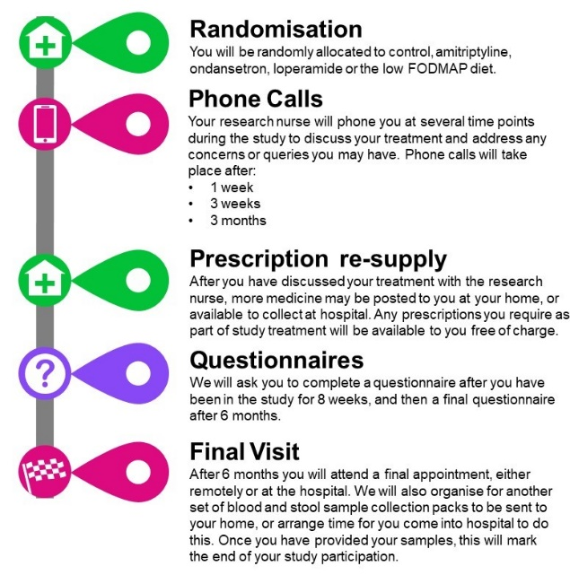
- We will ask you to record what dose of amitriptyline you are taking on diary cards throughout the study. This will help us to understand which dosage strategy is the most effective.

What else do I need to do?

- Phone calls

You will have a telephone call with a research nurse at several time points (Week 1, Week 3, Month 3 after randomisation) after you join the trial. This is to give you advice about your study medication and check if there are any problems. You will also be given the opportunity to ask any questions.

- Questionnaires

You will complete an online or postal questionnaire three times. To help you remember to complete the questionnaires, the research team at the CTRU will send you reminders by email and text messages to your mobile phone. If you do not have an email or mobile phone, the research nurse may phone you.

- Prescription re supply

Throughout the duration of the study your study medication will be posted to you at home, or available to collect from hospital. The amount of times you receive more medication will depend on the dosage that you chose to take. All of your prescriptions for amitriptyline will be free of charge.

- Final visit

You will attend a final appointment with your research nurse, either remotely or at the hospital after 6 months when you finish taking amitriptyline

What are the possible side effects of amitriptyline?

- Amitriptyline has been used widely for over 50 years and we are using it at a low dose in this study. Because of this, the side effects tend to be milder and tend to go away within a few days. Common side effects include:
- constipation
- dizziness
- dry mouth
- feeling sleepy, tired or weak. This is the reason we ask you to take the study drug at night.
- difficulty peeing
- headache

- Will amitriptyline interact with other medications?
We will check before you start that it will not interact with any other drugs you might be taking. Low dose amitriptyline can usually be given safely with drugs such as citalopram (Celexa); duloxetine (Cymbalta); fluoxetine (Prozac); sertraline (Zoloft) and trazodone (Desyrel). Drugs to avoid in case of potential interactions include: cyclobenaprine (Flexeril); topiramate (Topamax) and tramadol (Ultram).

You must let the study nurse or doctor know if you begin taking any over the counter medicines or herbal remedies while you are taking part in the study.

- Warning and precautions to use of amitriptyline
- Amitriptyline should not be taken by patients with certain heart conditions, severe liver disease, acute porphyria, during the manic phase of bipolar disorder or if taking certain medications. The research team will discuss this with you before you join the study.
- Please tell the research team if you have, or have had in the past, any medical problems, so that they can check if you are suitable to take amitriptyline. In particular you should mention any of the following:
- diabetes; epilepsy; history of psychosis or bipolar disorder; hyperthyroidism; increased intra-ocular pressure; phaeochromocytoma; prostatic hypertrophy (prostate gland enlargement); susceptibility to angle-closure glaucoma; difficulty passing urine; cardiovascular disease; chronic constipation; history of bipolar disorder.

