TREATMENT INFORMATION SHEET: ONDANSETRON

Management of diarrhoea in ulcerative colitis: multi-arm multi stage of low FODMAP diet, amitriptyline, ondansetron, or loperamide: MODULATE

We are inviting you to take part in a study called MODULATE

- You should read this leaflet if you are interested in joining MODULATE.

- If you are eligible and choose to take part, a computer will randomly allocate you to one of the treatment groups (interventions).

- This information leaflet contains information about the ondansetron intervention.

- Please take your time reading this information. Discuss it with your friends and relatives, if you wish.

- Make a note of any questions you might have and discuss them with your doctor or nurse.

Disclaimer: This research is funded by the NIHR HTA 17/33/03. The views expressed are those of the authors and not necessarily those of the NHS, the NIHR or the Department of Health and Social Care.
Contents

- What is ondansetron?

- How long will I be on the treatment for?

- How will my treatment be given?

- What else do I need to do?

- What are the possible side effects of ondansetron?

- Will ondansetron interact with other medications?

- Warning and precautions to use of ondansetron
How to contact us:

If you have any questions about this study, please talk to the research nurse at

<< Enter research team contact details including phone number and email address>>

Thank you for taking the time to read this information sheet.

- What is ondansetron?
- Ondansetron is a frequently used drug and has been used to treat nausea for more than 25 years. It has also been found to be helpful to relieve diarrhoea in patients with Irritable Bowel Syndrome (IBS). This was tested in a small study in people with IBSwith diarrhoea, and the results showed that it improved stool consistency, frequency, and urgency. In this study we want to test the effect of ondansetron in patients with stable ulcerative colitis (UC) who are still experiencing diarrhoea to see if we see the same effect.

- How long will I be on the treatment for?
- As part of the study, the maximum amount of time that you will be taking ondansetron will be 6 months.
- You can choose to stop taking ondansetron at any point should you wish, but please discuss this with your research nurse or doctor so they are aware of this and know the reasons why.
- After the study finishes, if you find that ondansetron is effective at relieving your symptoms you can talk to your doctor about continuing your treatment.

- How will my treatment be given?
- Ondansetron is a tablet treatment. You should swallow the tablet/s with a drink of water. You will receive your prescription for ondansetron from your research team. Each capsule contains 4mg of ondansetron.

- To start with, you will begin treatment on an initial dose of 4mg (one tablet) to be taken once daily. If after two days you are not noticing any change in your symptoms, you may wish to increase your dose by 4mg (one tablet) every 2 days until you find the right dose for you. The maximum amount of ondansetron you should take is 24mg, which is six tablets per day.

- In general, on days when you are taking your treatment you should take your first tablet in the morning before breakfast. After this you should try to take the remainder of your daily dose at evenly spaced time points throughout the day.

- During your first 2 weeks taking ondansetron you should adjust your dosage to achieve relief of your diarrhoea symptoms and find the right number of tablets per day for you. After the first 2 weeks, you should aim to stick to this optimal dosage. If a further change in dosage is required, you should discuss this with your research team.
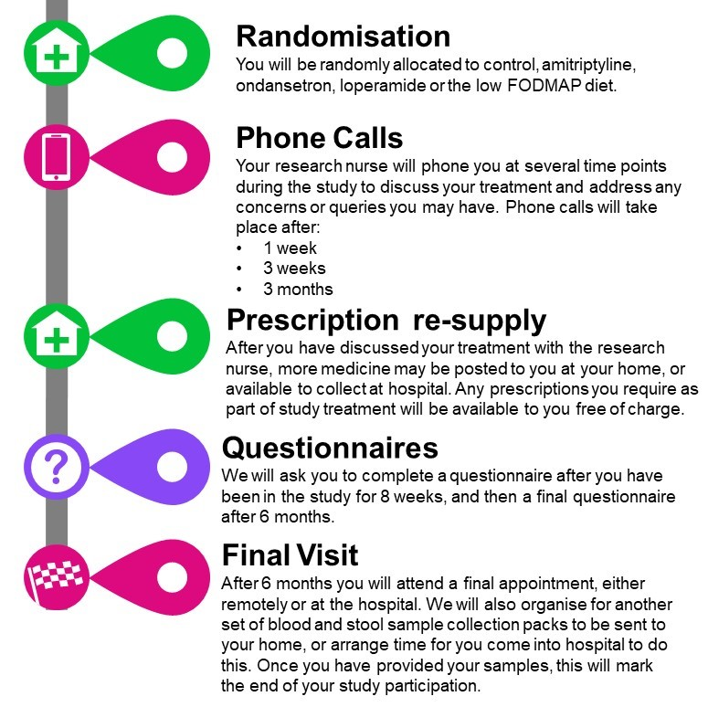
- We will ask you to record what dose of ondansetron you are taking on diary cards throughout the study. This will help us to understand which dosage strategy is the most effective.

What else do I need to do?

- Phone calls: You will have a telephone call with a research nurse at several time points (Week 1, Week 3 and Month 3 after randomisation) after you join the trial. This is to give you advice about your study medication and check if there are any problems. You will also be given the opportunity to ask any questions.

- Questionnaires: You will complete an online or postal questionnaire three times. To help you remember to complete the questionnaires, the research team at the CTRU will send you reminders by email and text messages to your mobile phone. If you do not have an email or mobile phone, the research nurse may phone you.

- Prescriptions: Throughout the duration of the study your study medication will be posted to you at home, or available to collect from hospital. The amount of times you receive more medication will depend on the dosage that you choose to takYour prescriptions will be free of charge.

- End of treatment: You will attend a final appointment, either remotely or at your hospital with your research nurse after 6 months when you finish taking loperamide.

- What are the possible side effects of ondansetron?
- At the doses we will be using the main side effects that could be expected are constipation and headache. Rarer side effects include abdominal pain, bloating, nausea, or vomiting, and rectal bleeding.

- Will ondansetron interact with other medications?

- We will check before you start that it will not interact with any other drugs you might take. Examples of drugs which may interact with ondansetron and should be avoided include doxorubicin, daunorubicin, trastuzumab, erythromycin, ketoconazole, amiodarone, atenolol, timolol, or St. John’s Wort. You must let the study nurse or doctor know if you begin taking any over the counter medicines or herbal remedies while you are taking part in the study.

- Warning and precautions to use of ondansetron?
- Before using ondansetron tell your research team if you have ever had heart problems; if you have an irregular heart beat (arrhythmia); liver problems; if you are allergic to medicines similar to ondansetron (e.g. granisetron or palonosetron); if you have problems with the levels of salts in your blood, such as potassium, sodium, or magnesium.
- There has been some evidence to show that ondansetron may cause some birth defects if taken whilst in the first trimester of pregnancy. If you suspect you could be pregnant you will not be allowed to take part in the trial at all. If you think you have become pregnant whilst on the trial, you must inform your research team immediately.

