TREATMENT INFORMATION SHEET:
LOPERAMIDE

Management of diarrhoea in ulcerative colitis: multi-arm multi stage of low FODMAP diet, amitriptyline, ondasetron, or loperamide: MODULATE

We are inviting you to take part in a study called MODULATE

- You should read this leaflet if you are interested in joining MODULATE.

- If you are eligible and choose to take part, a computer will randomly allocate you to one of the treatment groups (interventions).

- This information leaflet contains information about the loperamide intervention.

- Please take your time reading this information. Discuss it with your friends and relatives if you wish.

- Make a note of any questions you might have and discuss them with your doctor or nurse.

Disclaimer: This research is funded by the NIHR HTA 17/33/03. The views expressed are those of the authors and not necessarily those of the NHS, the NIHR or the Department of Health and Social Care.
Contents
- What is loperamide?

- How long will I be on the treatment for?

- How will my treatment be given?

- What else do I need to do?

- Why do some doctor advise not to take loperamide if you have IBD?

- What are the possible side effects of loperamide?

- Will loperamide interact with other medications?

- Warning and precautions to use of loperamide

How to contact us:

If you have any questions about this study, please talk to the research nurse at

<< Enter research team contact details including phone number and email address>>

Thank you for taking the time to read this information sheet.

- What is loperamide?

- Loperamide is a medication that is used to decrease the frequency of diarrhoea. You can buy loperamide from pharmacies and supermarkets. You may know it as ‘Imodium’ but is it also often simply labelled as ‘Anti Diarrhoea relief’. In this study we want to test the effect of loperamide in patients with stable ulcerative colitis (UC) who are still experiencing diarrhoea. This is because we believe that some patients with UC with stable disease who experience diarrhoea would like to use this drug, but it is not clear if it is of benefit, so they may receive conflicting advice from doctors.

- How long will I be on the treatment for?
- As part of the study, the maximum amount of time that you will be taking loperamide will be 6 months.
- You can choose to stop taking loperamide at any point should you wish, but please discuss this with your research nurse or doctor so they are aware of this and know the reasons why.
- After the study finishes, if you find that loperamide is effective at relieving your symptoms, you can talk to your doctor about continuing your treatment.

- How will my treatment be given?
- Loperamide is a capsule treatment. You should swallow the capsule/s with a drink of water. You will receive your prescription for loperamide from your research team. Each capsule contains 2mg of loperamide. You will have a choice regarding the dosage of your treatment.
- One option is to take loperamide ‘as required’ when you feel that you need diarrhoeal symptom relief. This would involve taking one capsule after every incidence of loose stools each day, up to a maximum of 16 mg (8 capsules) per day.
- The second option is to start the study on 2mg (one capsule) per day and to increase the dose to a maximum of 8mg (4 capsules) per day depending on your symptoms. You will be given further guidance on this option if you are randomised to receive this treatment.

- What else do I need to do?

- Phone calls

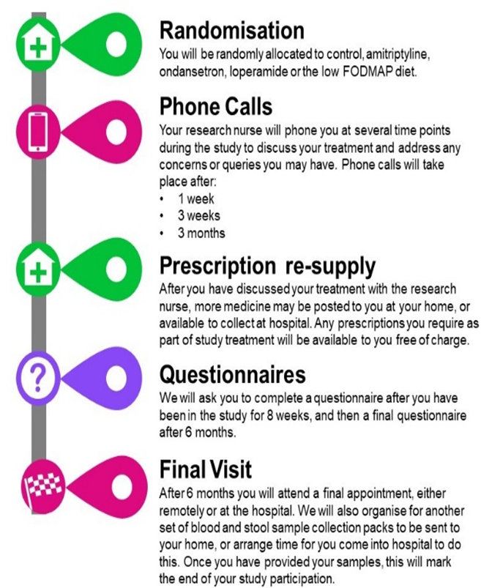
You will have a telephone call with a research nurse at several time points (Week 1, Week 3 and Month 3 after randomisation) after you join the trial. This is to give you advice about your study medication and check if there are any problems. You will also be given the opportunity to ask any questions.

- Prescription re supply

Throughout the duration of the study your study medication will be posted to you at home, or available to collect from hospital. The amount of times you receive more medication will depend on the dosage that you chose to take.

- Questionnaires

You will complete an online or postal questionnaire three times. To help you remember to complete the questionnaires, the research team at the CTRU will send you reminders by email and text messages to your mobile phone. If you do not have an email or mobile phone, the research nurse may phone you.

- Final visit

You will attend a final appointment, either remotely or at hospital with your research nurse after 6 months when you finish taking loperamide.

- Why do some doctor advise not to take loperamide if you have IBD?

- Loperamide stops the natural contracting motion of the colon, which is why it is helpful if you have diarrhoea. However, if there is inflammation in your colon (if you have active UC where inflammation is present) this effect can cause problems, as a build-up of faecal matter can put pressure on the inflamed colon, potentially causing damage. This is referred to as toxic mega colon.

- Therefore, in order to take part in MODULATE, we will check that there is no current inflammation in the colon (using the blood test, stool sample and, if your gastroenterologist is still unsure, a flexible sigmoidoscopy) to ensure that it is safe and appropriate to use loperamide.

- What are the possible side effects of loperamide?
- Loperamide is a frequently used drug and as such can be purchased at most supermarkets and pharmacies.
- The common side effects for this medication are listed below:
- Constipation
- Headaches
- Nausea

These have been reported by at least 1% of people taking this treatment. Many of these side effects can be managed and some may go away on their own over time.

Other rarer side effects include dizziness, drowsiness, dry mouth, skin reactions, or vomiting.

- Will loperamide interact with other medications?

We will check before you start that it will not interact with any other drugs you might take. Examples of drugs that may interact with loperamide and should be avoided include ceritinib, desmopressin, dronedarone, eliglustat, lapatinib, mirabegron, opicapone, paritaprevir, pibrentasvir, pitolisant or velpatasvir. You must let the study nurse or doctor know if you begin taking any over the counter medicines or herbal remedies while you are taking part in the study.

- Warning and precautions to use of loperamide
- Loperamide should not be taken if you have active UC (where inflammation is present) as confirmed by results from the blood test, stool sample and flexible sigmoidoscopy (if required). In order to take part in this study we will confirm that you do not show any evidence of active UC. If we find evidence of active disease during our eligibility screening tests, then you will not enter the study and you will need to discuss other treatment options with your doctor.
- Loperamide is broken down by the liver. Therefore, if you suffer from liver disease or have reduce liver function then this may cause this medication to build up in your body. If you have liver problems you will need to discuss with your doctor whether it is safe for you to take part in the trial, as there is a chance that you may be allocated to receive Loperamide as a treatment.
- Loperamide works to change the movement of your intestinal wall, slowing the movement of fluid through the gut. Therefore, as the drug works to stop diarrhoea, in some cases this can result in associated constipation. This happens in around 3% of people.

