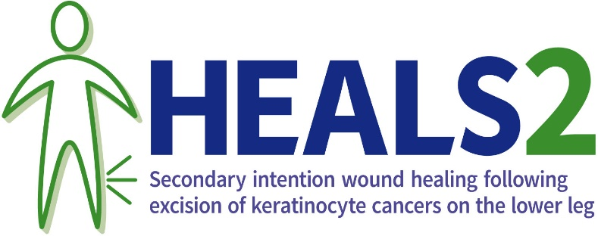
Delete this line, then print on Trust/Hospital headed paper

Dear <<insert name>>
Thank you again for choosing to take part in this study and for the time and effort you put into the study until now. By deciding to take part you have made an important contribution to improving the healthcare of patients like you in future.
Why has my participation stopped?
As you will have been told by your study doctor or nurse, unfortunately this study is no longer suitable for you. This decision was not taken lightly, but was taken in the interests of your health and wellbeing. Do talk to your doctor or nurse about this if you have any questions or concerns.
What happens now I have stopped taking part?
The research team will no longer telephone you to ask about your wound, or ask you to come to hospital to see the research team. We won’t ask you to complete any more questionnaires.
What will happen to my care now?
Your care will be unaffected and will continue as guided by your nurse or doctor.
What will happen to the information you have collected about me?
We will keep the information we have already collected and include it in the study results. This makes the study results more reliable. You may want to look again at the information sheet you were given before you agreed to take part in this study, as it contains some information about stopping your involvement. If you don’t have a copy of that anymore, speak to your study doctor or nurse to get another one, copies are also available on our website http://ctru.leeds.ac.uk/heals2/
When can I find out the results of the study?
A copy of the results will be available on the website. http://ctru.leeds.ac.uk/heals2/
What if I have a complaint?
If you wish to complain about any aspect of the way you have been treated, please contact your research doctor in the first instance or by contacting your local Patient Advice and Liaison Service (PALS) https://www.nhs.uk/service-search/other-health-services/patient-advice-and-liaison-services-pals.

Can I give any feedback about my experience taking part in this study?
If you would like to give any general feedback about your experience taking part in the study, we would very much like to hear from you, or you may not want to do this. Either is completely fine.
Feel free to contact your study doctor or nurse if you would like to tell them anything about your experience taking part in the study. Any information you give will be treated sensitively and confidentially. Alternatively, you can complete a short questionnaire on the website http://ctru.leeds.ac.uk/heals2/
Can I get involved in any other research, or help to improve how research is done in the future?
Yes, please see https://bepartofresearch.nihr.ac.uk/ for opportunities to take part in other research studies, or different ways to become involved research without taking part in a study (such as being a research champion, taking part in focus groups or developing materials for a research study).

Kind regards,

<<Add PI details >>

HEALS2 website QR code

