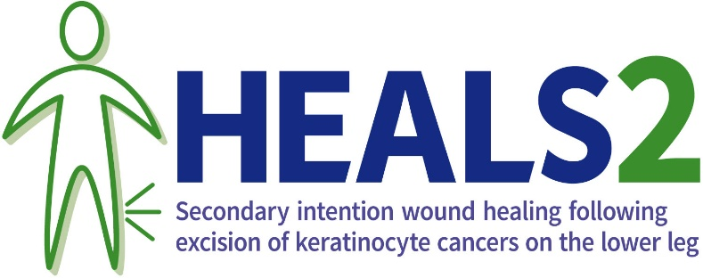
Delete this line, then print on Trust/Hospital headed paper

Dear <<insert name>>,
Thank you again for choosing to take part in this study and for the time and effort you put into the study until now. By deciding to take part you have made an important contribution to improving the healthcare of patients like you in future.
Unfortunately, we have not been able to get in touch with you since [date of last contact] about your involvement in the HEALS2 study. We therefore assume that you have stopped taking part in the study for now.
We hope you are doing as well as possible since your last involvement in the study. We would encourage you to contact the study team if you need anything, or just to say how you are doing. Our contact details are provided below.
As you have not specifically said you want to stop all your contributions to this study, we may try again in future to contact you. You can ask us not to contact you by get in touch with us directly (contact details including telephone number available at the end of this letter) or via the study website http://ctru.leeds.ac.uk/heals2/.
If you feel unable to continue with the full study schedule now, you can still contribute without giving as much of your time.
For example:
- Continuing to receive phone calls but no longer completing any questionnaires OR
- No longer receiving any phone calls but carry on completing questionnaires
- Continuing with your compression if you had been allocated to this treatment
If you do get back in touch and attend any routine hospital appointments, any relevant information from these appointments will still be used for the study, unless you ask us not to. We may also get in touch with your GP to find out how you are doing.
This is our understanding of what is happening with your participation in the study now:
- You will no longer be asked to complete any study questionnaires
- You won’t attend any more hospital visits specifically for the study
- You are still happy for relevant information about you from future routine healthcare appointments to be used for the study
- You are still happy for the information collected about you so far to be used for further research projects, as long as this is done in a way that means your identity is not shared with anyone outside the research team
- Your care is continuing under the guidance of your usual care team. This may or may not involve compression therapy
If this does not look right, please get in touch. Otherwise, we will assume that this information is correct.
What will happen to the information you have collected about me?
Remember that there are some limits on completely ending all your involvement in the study. You can find more details about these in the information you were given before you agreed to take part in this study. If you don’t have a copy of that anymore, a copy is available on our website http://ctru.leeds.ac.uk/heals2/. We need to keep the information that we have collected about you until now and use it in the study analysis.
Can I find out the results of the study?
A copy of the results will be available on the website. http://ctru.leeds.ac.uk/heals2/
What if I have a complaint?
If you wish to complain about any aspect of the way you have been treated, please contact your research doctor in the first instance or by contacting your local Patient Advice and Liaison Service (PALS) https://www.nhs.uk/service-search/other-health-services/patient-advice-and-liaison-services-pals.
Can I give any feedback about my experience taking part in this study?
If you would like to give any general feedback about your experience taking part in the study, we would very much like to hear from you. You don’t have to give anyone a reason for stopping your involvement in this study and you may not want to do this which is completely fine.
However, as mentioned in the information you were given before you agreed to take part, it can be beneficial for the study if you are happy to give a reason. People analysing the study will be able to understand the results better. It would be particularly helpful to know if you stopping your involvement has anything to do with changes in your health. We would not need to know any more detail than that.
Feel free to get in touch if you would like to tell us anything about why you have decided to stop taking part in the study. Any information you give will be treated sensitively and confidentially. Alternatively, you can complete a short questionnaire on the website http://ctru.leeds.ac.uk/heals2/
Can I get involved in any other research, or help to improve how research is done in the future?
Yes, please see https://bepartofresearch.nihr.ac.uk/ for opportunities to take part in other research studies, or different ways to become involved research without taking part in a study (such as being a research champion, taking part in focus groups or developing materials for a research study).
Kind regards,

<<add PI contact details>>
<<add PI/research team contact phone number>>

HEALS2 website QR code:

