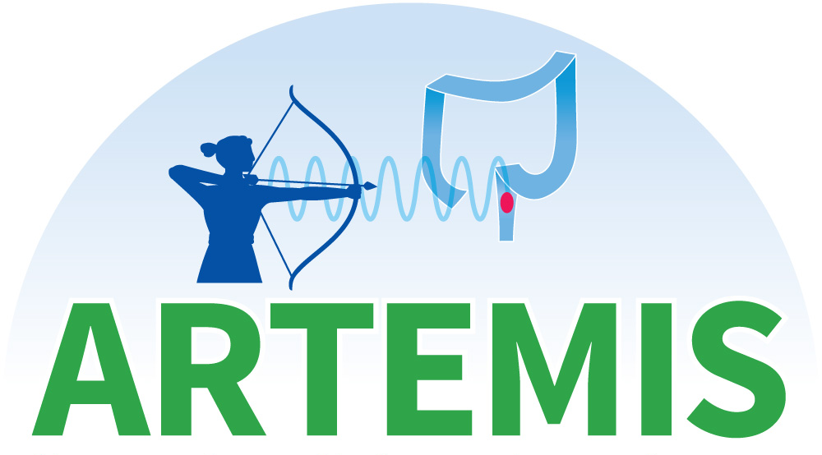

Augmenting RadioTherapy in REctal Cancer to Minimise Invasive Surgery

KEY FACTS SHEET
(LCCRT / CAPOX)




Sponsored By: Supported by:

AN0025 for 2-weeks prior to RT
4 6 9 12 18 24 30
Half randomised to each arm
Decision to enter trial

6-month primary endpoint

CAPOX chemotherapy for 12 weeks
(A MRI scan will be performed 16 weeks after start of RT and surgery considered if there is a poor response to treatment)
Patients with a complete response to treatment will go on active surveillance with scans and endoscopies at 9, 12, 18, 24 and 30 months from the start of RT
Patients who do not achieve a complete response will have surgery and then active surveillance
Long Course chemoradiotherapy over 5 weeks
AN0025 trial drug taken for a total of 22 weeks
3-week gap to recover from radiotherapy
CAPOX chemotherapy for 12 weeks
(A MRI scan will be performed 16 weeks after start of RT and surgery considered if there is a poor response to treatment)
CT and MRI scan at 24-26 weeks after start of RT to determine response
PRIMARY ENPOINT
50%
50%
4-week gap
Total of 20 weeks since start of radiotherapy
Long Course chemoradiotherapy over 5 weeks
3-week gap to recover from radiotherapy

What is the ARTEMIS study?
We would like 140 volunteers with rectal cancer who are interested in the chance of getting a new trial treatment with the hope of getting rid of the cancer without the need for surgery or a colostomy (stoma).

Currently, chemoradiation followed 8-12 weeks later by radical surgery is the standard of care for patients with your type of cancer. However, radical surgery can cause bowel, bladder and sexual dysfunction. A stoma may also be required and it can also lead to surgical complications and death.

This study wants to find out if the use of immunotherapy agent AN0025, together with 3 months of chemotherapy after the initial chemoradiotherapy, can help improve the chance of the cancer completely disappearing.

In this study everybody will receive chemoradiotherapy (radiotherapy and oral capecitabine) followed by 3 months of chemotherapy (CAPOX). Half of the patients will also be randomised to receive an additional oral immunotherapy. ‘Randomised’ means that a computer will select at random whether or not you receive the immunotherapy agent and not your clinician.

What is involved? - Before you enter

Before you enter the study you will be given a Patient Information Sheet that will contain all the information you need to know about the study. Please take as much time as you need to look at all the information and ask your doctor or research nurse any questions you may have about the study before deciding to take part. It is completely your own decision whether to enter into this study. If you do decide to enter then you and your doctor will go through your Consent Form together and you will both sign and date it.

